**Christopher King**

**2018141521058**

**Mechanical Design 2**

**Class Section 01**

**09/09/2021**

# **Problem 1**

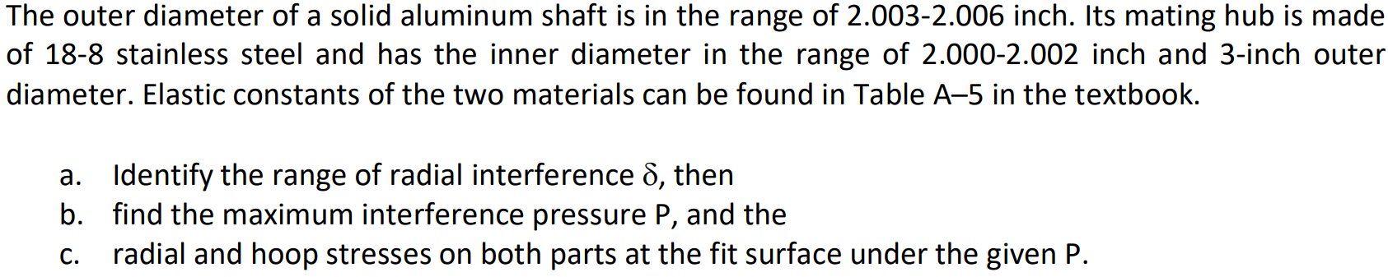

**Solution:**

1. For this question, we are asked to identify the range of radial interference .

Therefore, the range of radial interference is .

1. For this question, we are asked to find the maximum interference pressure .
2. For this question, we are asked to find the radial and hoop stresses on both parts at the fit surface under the given .

Radial stresses:

Hoop stresses:

# **Problem 2**

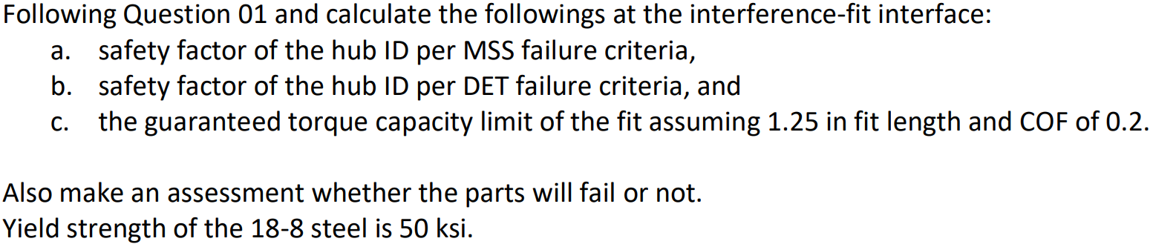

**Solution:**

1. For this question, we are asked to calculate the safety factor of the hub ID per MSS failure criteria.
2. For this question, we are asked to calculate the safety factor of the hub ID per DET failure criteria.
3. For this question, we are asked to calculate the guaranteed torque capacity limit of the fit assuming 1.25 in fit length and COF of 0.2.
4. For this question, we are asked to make an assessment whether the parts will fail or not.

Because the safety factors of the hub ID by two criteria are both less than 1, the parts will fail.

# **Problem 3**

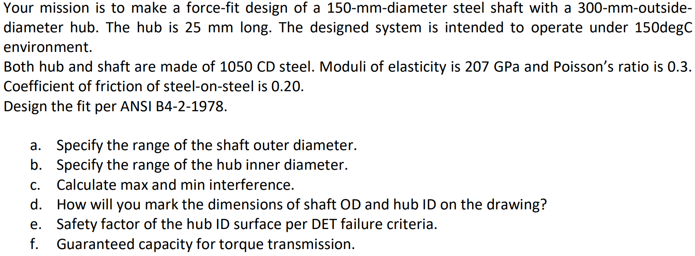

**Solution:**

1. For this question, we are asked to specify the range of the shaft outer diameter.

According to Table 7-20, the symbol for force-fit is H7/u6.

The basic size of the system is equal to . According to Table A-11, the tolerance grade of H7 is and the tolerance grade of u6 is .

And according to Table A-12, the fundamental deviation for u6 is .

Therefore, the minimum shaft outer diameter is equal to

And the maximum shaft outer diameter is equal to

Therefore, the range of the shaft outer diameter is .

1. For this question, we are asked to specify the range of the hub inner diameter.

The minimum hub inner diameter is equal to

And the maximum hub inner diameter is equal to

Therefore, the range of the shaft outer diameter is .

1. For this question, we are asked to calculate max and min interference. The maximum interference is equal to

The minimum interference is equal to

1. For this question, we are asked to mark the dimensions of shaft OD and hub ID on the drawing.  
   The way to mark the dimensions of shaft OD and hub ID on the drawing is shown in figure below:

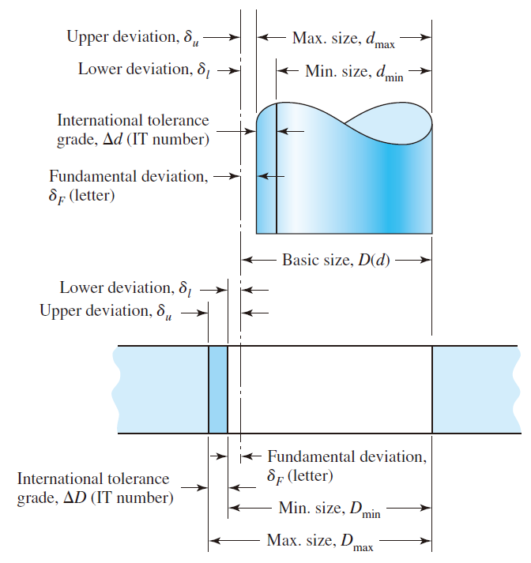

1. For this question, we are asked to determine the safety factor of the hub ID surface per DET failure criteria.

Radial stresses:

Hoop stresses:

From Table A-20, I can know that the yield strength of 1050 CD steel is equal to

1. For this question, we are asked to determine the guaranteed capacity for torque transmission.